Janeka Martin
QKN1 — QKN1 Task 1: Program Planning
Analytics Programming — D598

Scenario

You have been hired by a small investment company that manages an equity fund comprised of 150 U.S. companies across multiple industries. The fund managers are looking to rebalance the fund’s holdings and would like you to provide an analysis of the companies’ performance based on data from the most recent quarter. The data can be found in the supporting documents section as “D598 Data Set”.
To aid in your analysis you must write programs in Python or R to perform the following tasks:
• Import the data file into a data frame.
• Identify any duplicate rows in the data set.
• Group all IDs by state, then run descriptive statistics (mean, median, min, & max) for all numeric variables by state and store this result as a new data frame. (Code should be modified from “D598 Task 2 Original Code” in the supporting documents section)
• Filter the data frame to identify all businesses with debt-to-equity ratios that are negative.
• Create a new data frame that provides the debt-to-income ratio for every business in the data set. Debt-to-income ratio is defined as long-term debt divided by revenue.
• Concatenate the debt-to-income ratio data frame you created with the original data frame.

In this task you will prepare for your program writing by doing the following:
- Create a flowchart for a program to perform the required task.

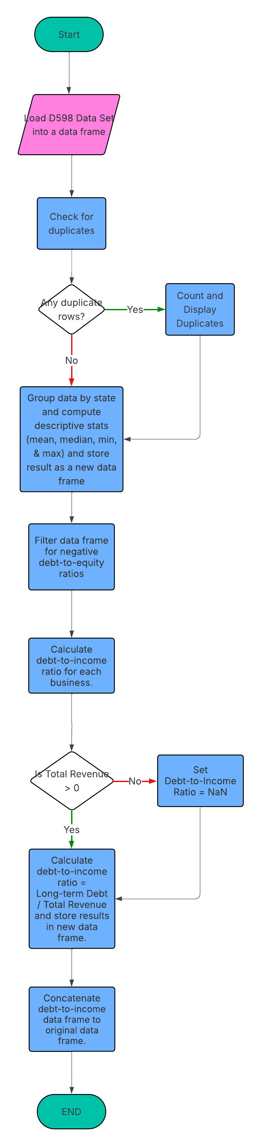
- Write pseudocode for a program to perform the required task.

BEGIN

- Load Libraries
  - Pandas
  - numpy
- Load D598 Data Set into a data frame
- Check for duplicate rows
IF duplicates exist:
Display count and drop duplicates
- Group data by state and compute descriptive stats (mean, median, min, & max)
  - Store state statistics in new data frame
- Filter data frame for negative debt-to-equity ratio
- Calculate debt-to-income ratio for each business
IF Total Revenue > 0:
SET Debt-to-Income Ratio = NaN
ELSE:
Calculate debt-to-income ratio and store results in a new data frame.
- Concatenate debt-to-income data frame to original data frame.
END

C. Provide an explanation of the relationship between the flowchart and pseudocode that does the following:

- Describe the logic behind the flowchart and pseudocode.

The flowchart provides a visual representation that illustrates the sequence of actions and decisions made when planning to develop code for a program. To represent each phase of the program, shapes such as arrows, rectangles, and diamonds are used to plan out and clearly show steps and decisions (GeeksforGeeks, n.d.). A flowchart also provides a common understanding for all technical backgrounds to be aligned on a program's outcome. The flowchart developed for the analysis outlines the process, beginning with inputs from an Excel file, validations such as checking for required columns and missing values, core data transformations, and exporting the results.

The pseudocode captures the same steps in plain English rather than specific programming syntax (Codecademy, n.d.). By creating pseudocode, programmers have an organized and readable bridge between the problem idea and actual code (Codecademy, n.d.). Additionally, by including beginner-safe checks such as verifying columns, the pseudocode reduces the likelihood of runtime errors and clarifies intent before any Python is written (Codecademy, n.d.).

- Explain the alignment between flowchart and pseudocode.

According to Codecademy (n.d.), using a pseudocode and flowchart approach together provides both textual and visual ways to understand and communicate how a program works. Each flowchart step maps directly to a pseudocode step. This one-to-one mapping reflects best practices for using a flowchart to visualize the flow of a program and its decisions, and pseudocode to articulate the same logic in ordered, implementation-ready steps (Codecademy, n.d.; GeeksforGeeks, n.d.). The result is a consistent blueprint that’s easy to translate into Python.

D. Acknowledge sources, using in-text citations and references, for content that is quoted, paraphrased, or summarized.

Codecademy. (n.d.). Pseudocode and flowchart: Complete beginner’s guide. https://www.codecademy.com/article/pseudocode-and-flowchart-complete-beginners-guide

GeeksforGeeks. (n.d.). Introduction to flowcharts. https://www.geeksforgeeks.org/competitive-programming/an-introduction-to-flowcharts/

